MangoDB part-2

Login Through Putty:

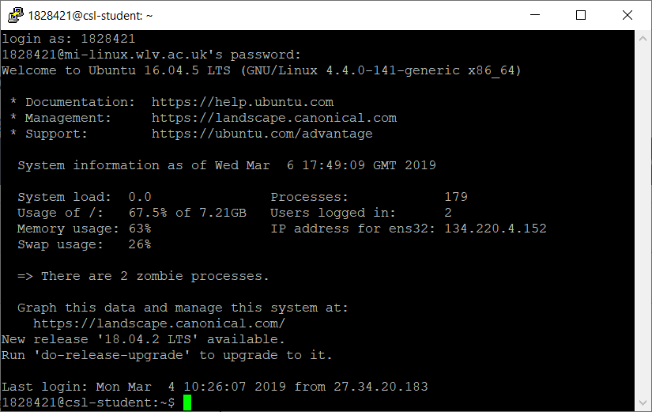

Running Mango DB and showing collection and counting weather:

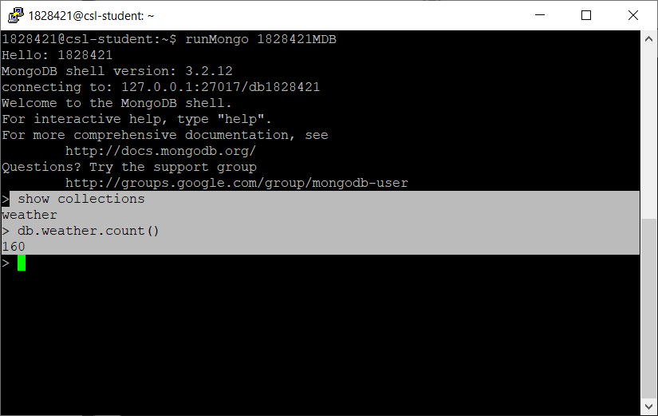

Explore the Documents:

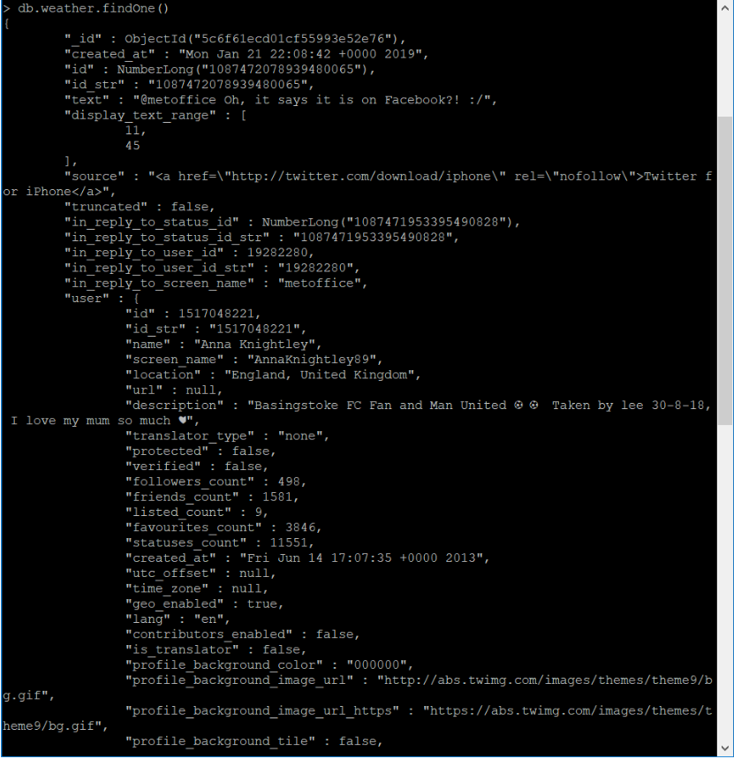

Distinct User:

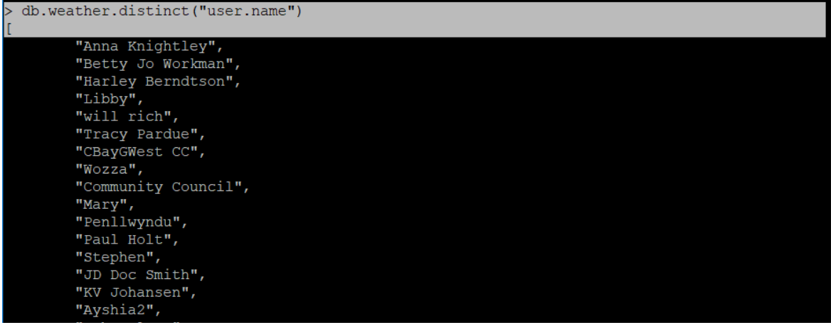

Distinct Values and Tweet saying:



Nested Layer Document Access:

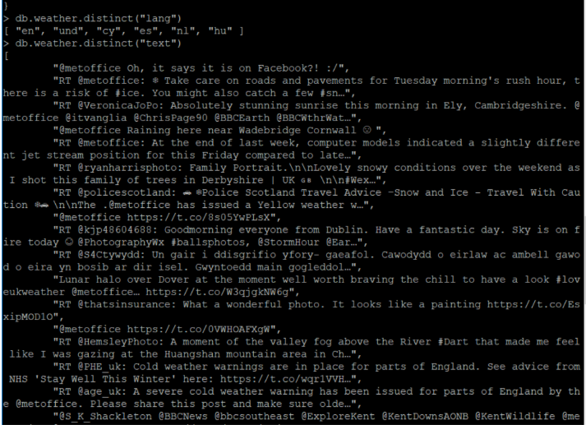

Searching specific values of field:

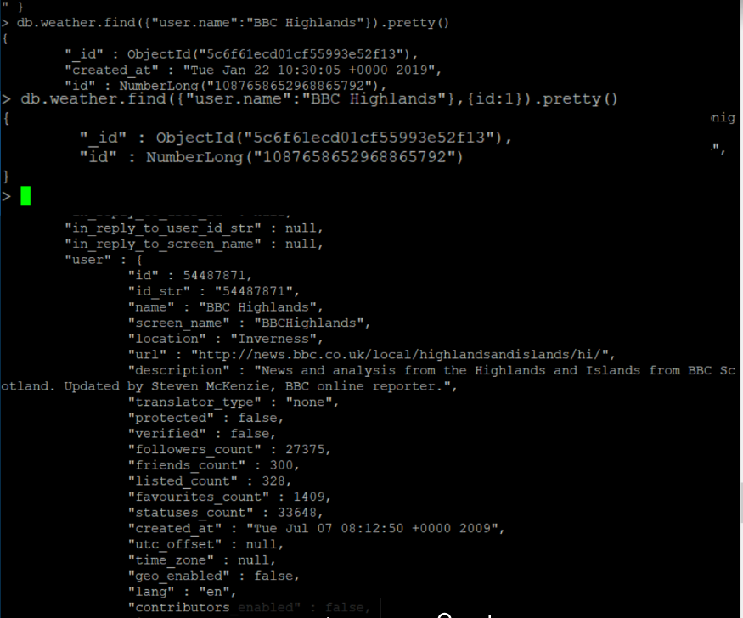

Filtering:

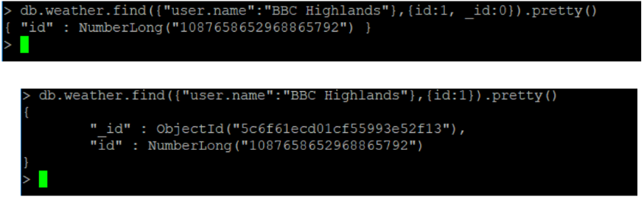

Pattern Matching:

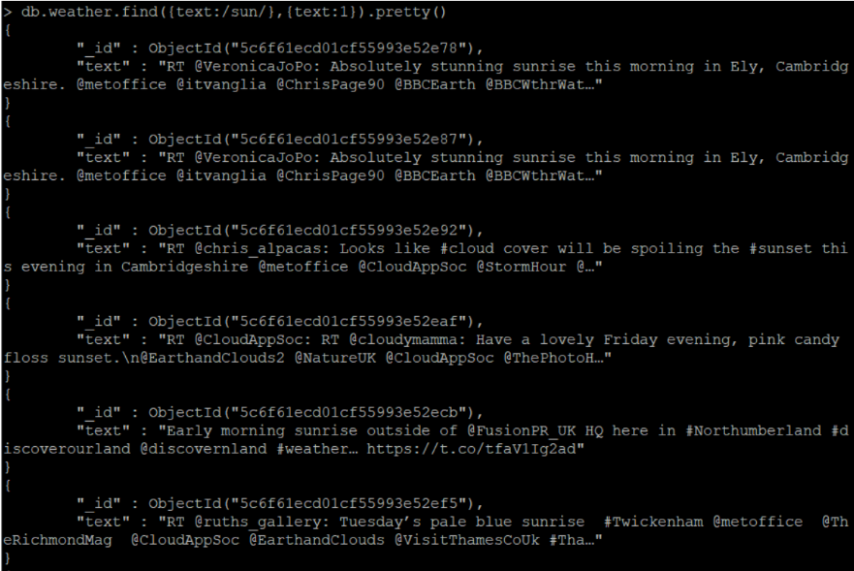

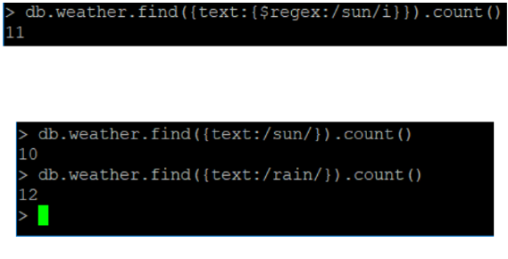

Regex:



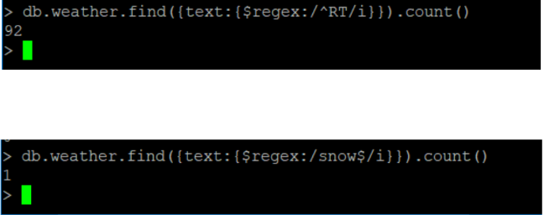

Regex Vs Pattern/Syntax:

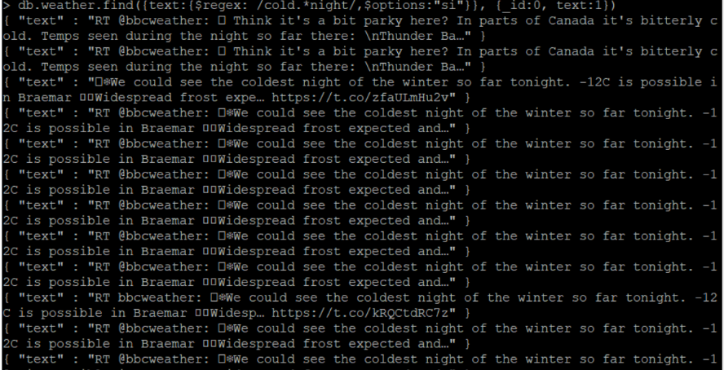

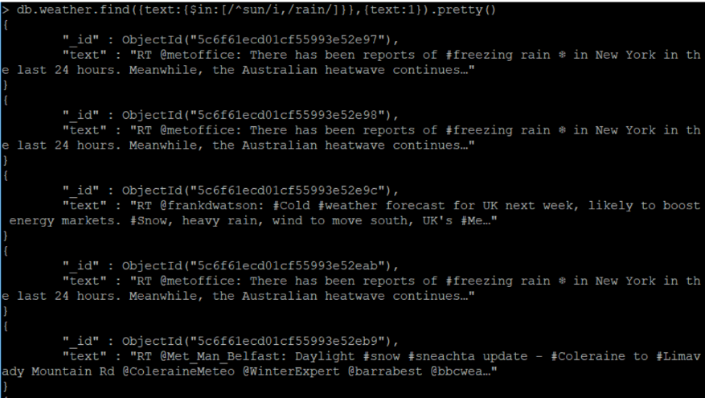

2.

Index Creation:

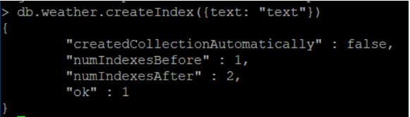

Searching with an Index:

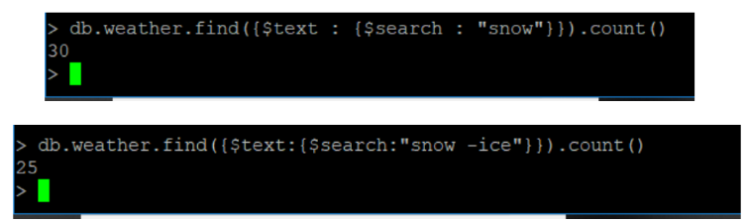

Index Get:

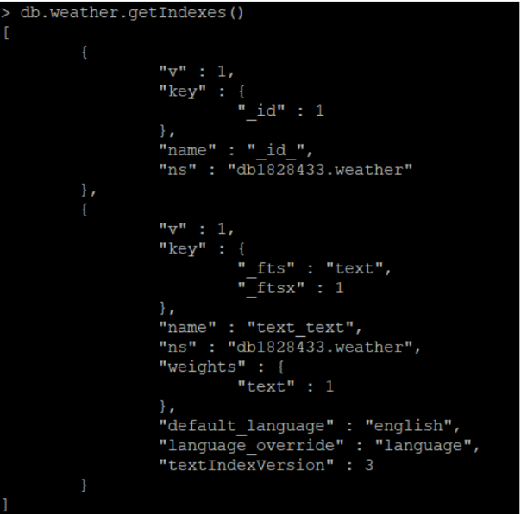

Index Drop:

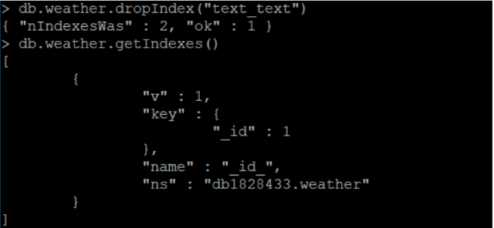

3.

Operations:



Null & Boolean:

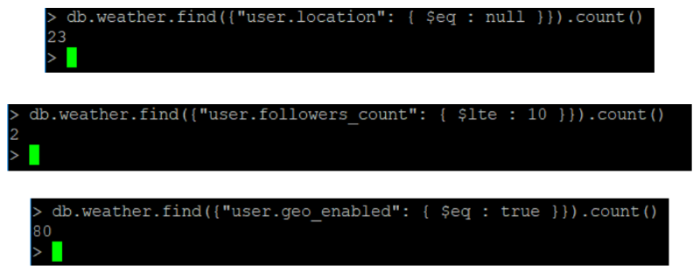

Finding Nested:



Where Clause:

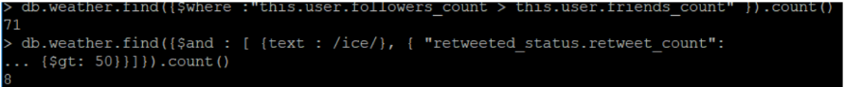

4.

Aggregate & Group:

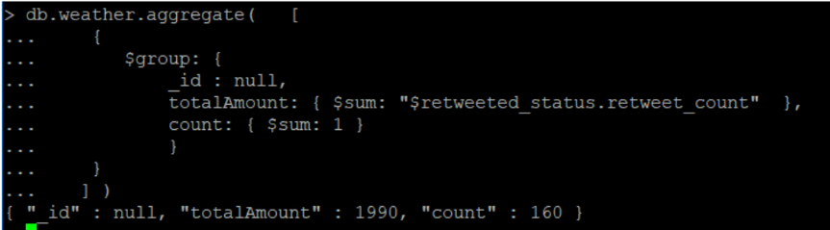

Finding error:

